
Part 2 - Sheet 2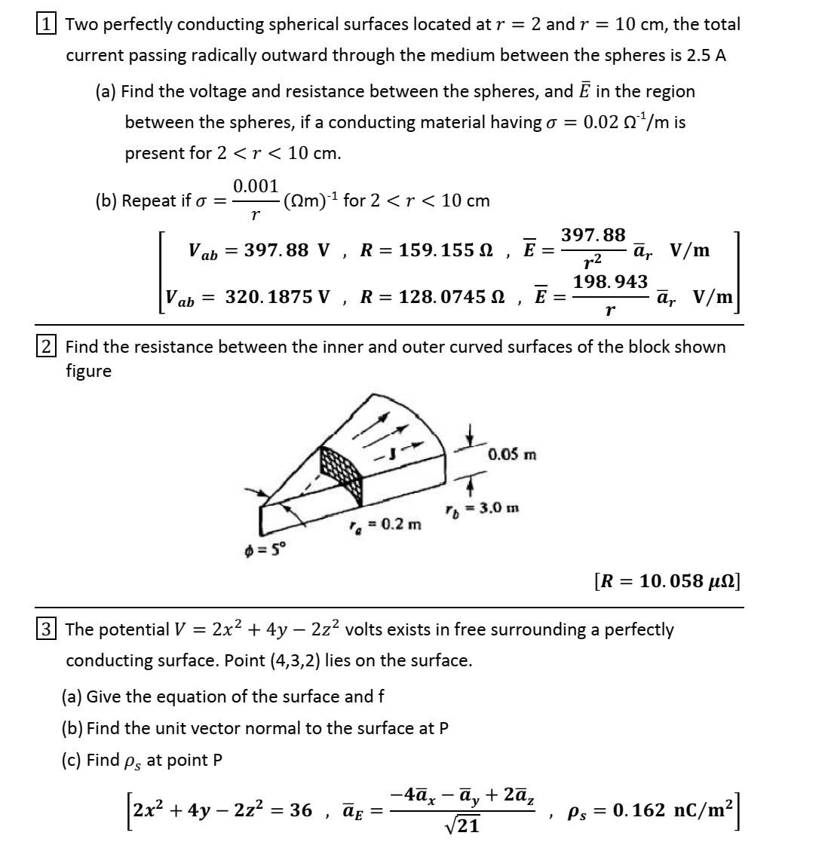

$\boxed{4}$ 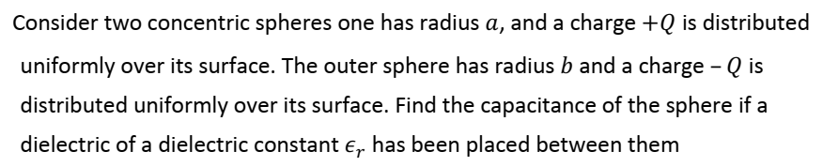
$\boxed{5}$
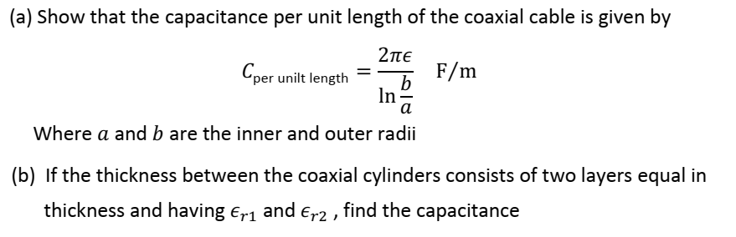
$\boxed{6}$ 